**MapKit Tutorial**

1. Create **New Single View Application**, **Product Name:** CrimeMap  
   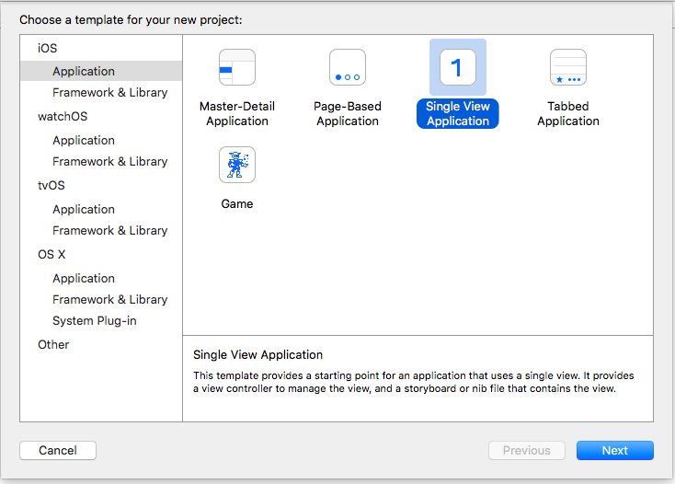  
   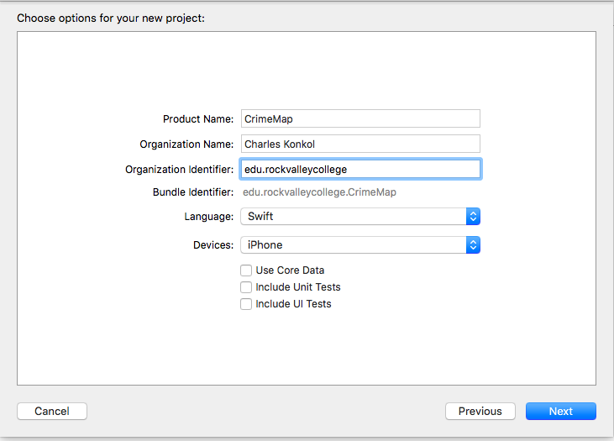
2. Set Device Orientation to **Portrait**
3. Select **Main.Stroyboard**
4. Hide Document Outline  
   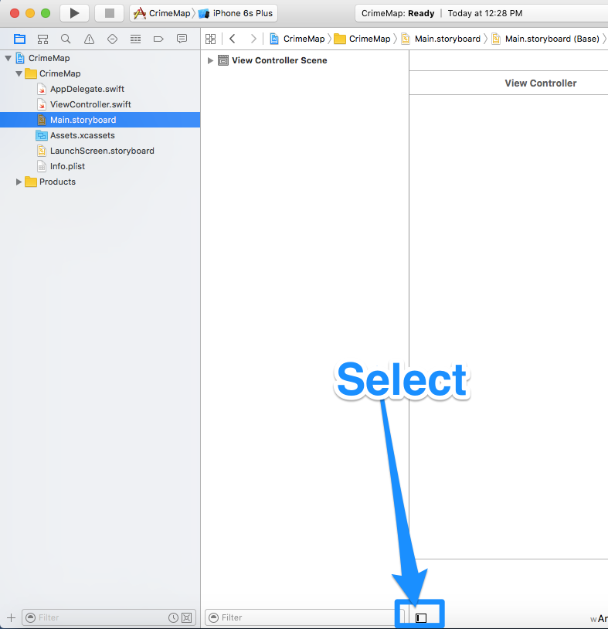
5. Add Objects to View Controller
   * Navigation Bar
   * Map Kit View
   * Label
   * UISlider  
     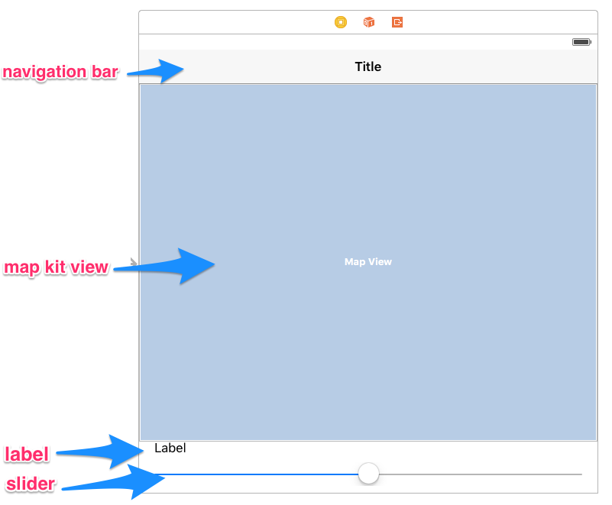
6. Add Imports to top of viewcontroller.swift

import MapKit

import Foundation

1. Create Outlets & Actions
   * Navigation Bar
     1. Name: navigationBar
   * Map Kit View
     1. Name: mapView
   * Label
     1. Name: lblCrimeRange
   * Slider
     1. 2 Action Events
     2. Name: DateSlider
        + Value Changed  
          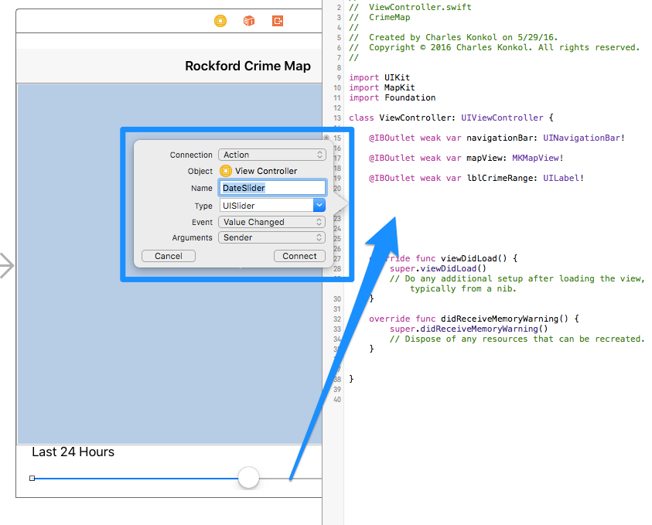
     3. Name: DateSliderUp
        + Touch Up Inside   
            
           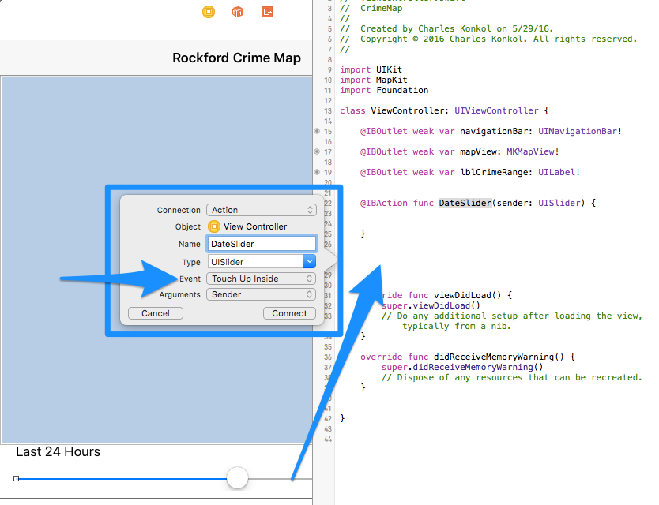
        + 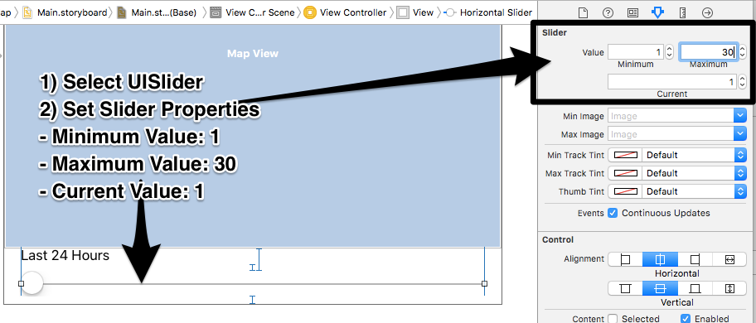
2. Add New Class
   * Control Click on **CrimeMap** folder and select **New File**
   * 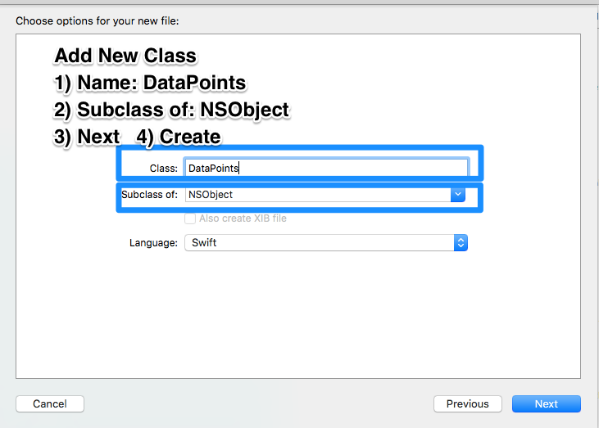
3. Add Code. Follow Steps in Code
   * [ViewController.swift](https://raw.githubusercontent.com/chukon/CrimeMap/master/CrimeMap/ViewController.swift)
   * [DataPoints.swift](https://raw.githubusercontent.com/chukon/CrimeMap/master/CrimeMap/DataPoints.swift)
4. Align Objects
   * Editor > Resolve Auto Layout Issues > Reset to Suggested Constraints
5. Add Icon
   * User Pixlr.com to create a 1024x1024
   * <https://makeappicon.com/>